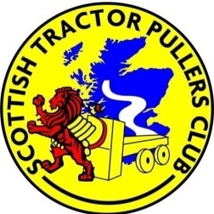

FARM CLASS TRACTOR PULLING RULES & ENTRY FORM Angus Show 7th & 8th June 2019

- Drivers must obey track staff instructions

- Tractors to be driven in a safe and courteous manner in pit area and on return road (maximum speed 10 mph)

- Tractors to be split into classes according to weight (Calibrated weighbridge onsite. Tractors to arrive in good time to attend drivers meeting plus get weighed in)

- Up to 7ton
- Up to 9ton
- Up to 11ton

- No excessive ballast

- Pull from pick-up hitch with adaptor link (provided)

- Anyone considered to be under the influence of alcohol or drugs will not be permitted to compete

- STPC committee decision is final

ENTRY FEE £10.00 PER CLASS

I agree to the above rules and conditions

Name............................... Tractor make & model................................................

Tractor reg. No............................... …. Signature.................................................

